*Final Year Project*

*On*

*REVIEW ON THEORY BEHIND GENERATION OF SYNTHETIC HYDROGRAPH AND INSTANTANEOUS UNIT HYDROGRAPH*

*Under the Guidance of Prof. SUBHASHISH CHATTERJEE*

*Submitted on the partial Fulfilment of the requirement for the*

*Award*

*Of*

*BACHELOR OF TECHNOLOGY (CIVIL ENGINEERING)*

**

*DEPARTMNET OF CIVIL ENGIMNNEERING*

*TECHNO MAIN SALT LAKE(TMSL)*

*EM-4/1, Sector-V, Salt Lake, Kolkata-700091*

A Report on

*REVIEW ON THEORY BEHIND GENERATION OF SYNTHETIC HYDROGRAPH AND INSTANTANEOUS UNIT HYDROGRAPH*

By

Swapnaneel Ghosh

Sayanti Sahu

*Under the Guidance of Prof. SUBHASHISH CHATTERJEE*

*(Professor of Techno Main Salt Lake)*

**

*DEPARTMNET OF CIVIL ENGIMNNEERING*

*TECHNO MAIN SALT LAKE(TMSL)*

***CERTIFICATE***

This is to certify that Swapnaneel Ghosh, Roll No.: 13001319052, Registration No.: 016160 and Sayanti Sahu, Roll No.: 13001320085, Registration No.: 201300101320014 have carried out the project work entitled as **“REVIEW ON THEORY BEHIND GENERATION OF SYNTHETIC HYDROGRAPH AND INSTANTANEOUS UNIT HYDROGRAPH”** as a part of the curriculum for the B. Tech Degree in Civil Engineering under Maulana Abul Kalam Azad University of Technology for the year 2019-2023. This project report is approved by the undersigned only for the purpose for which it is submitted. The candidates are entirely responsible for statement, opinions and conclusions contained herein.

**DR. ARUP SAHA CHOUDHURY Prof. SUBHASHISH CHATTERJEE**

HEAD OF DEPARTMENT PROFESSOR

CIVIL ENGINEERING DEPARTMENT CIVIL ENGINEERING DEPARTMENT

TECHNO MAIN SALT LAKE TECHNO MAIN SALT LAKE

***ACKNOWLEDGEMENT***

A training project is an excellent opportunity for learning and self-development. We consider ourselves very lucky and honoured to have so many wonderful people lead us through in completion of this project. It is grateful for us to acknowledge the kind of help and guidance received by us during my project work. We were fortunate enough to get support from a large number of people to whom I shall always remain grateful.

We sincerely thank Professor Subhashish Chatterjee for assigning such a good project, which has enriched our knowledge, and experience and getting acclimatized in a fit and final working ambience of a site.

We express our deepest thanks to Prof. Subhashish Chatterjee (Professor of Civil Engineering, Techno Main Salt Lake) for his support, cooperation and inspiration.

The in-time facilities provided by the department making this report are also equally acknowledgeable.

We would like to convey our thanks to every teaching and non-teaching staffs of the Department of Civil Engineering of our college for their invaluable help and support throughout the period of making this report. We are also grateful to our classmates for their help, encouragement and invaluable suggestions.

Finally, yet more importantly, we would like to express my deep appreciation to each of our group members for their perpetual support and encouragement during this period.

Techno Main Salt Lake

(Signature) (Signature)

(Name of Candidate) (Name of Candidate)

***ABSTRACT***

This synopsis is made to realize the importance of Synthetic Unit Hydrograph and also the necessities of such a thing even after already having a hydrograph. The main aim is to understand the various techniques needed for establishing a relationship between the basin characteristics and the unit graph characteristics, for a unit rainfall of an ungauged basin; wherein the Synthetic Unit hydrograph theory is of utmost importance. Our goal is to study Snyder’s theory (1938) for Synthetic Unit hydrograph in detail, based on a study of a large number of catchment basins in the Appalachian Highlands of Eastern United States, developed a set of empirical equations, connecting the basin characteristics with the unit graph characteristics; thereby ultimately develop a synthetic unit hydrograph on our own at the end of the project. The synopsis also includes the analysis of three hydrograph characteristics which Snyder found relationships between; those are effective rainfall duration(tr), the peak direct runoff rate(qp) and the basin lag time(ti). Synopsis is mentioned about our way of approach and also the purpose of simulation of basin diffusion by estimating the basin lag based on a certain formula or procedure.

***CONTENTS***



|  |  |  |
| --- | --- | --- |
| **SL NO** | **TOPICS** | **PAGE NO** |
| 01 | CERTIFICATE | 3 of 39 |
| 02 | ACKNOWLEDGEMENT | 4 of 39 |
| 03 | ABSTRACT | 5 of 39 |
| 04 | INTRODUCTION | 7 of 39 |
| 05 | OBJECTIVE | 7 of 39 |
| 06 | LITERATURE REVIEW | 8 of 39 |
| 07 | RUNOFF | (9-27) of 39 |
| 08 | S - CURVE | (27-30) of 39 |
| 09 | SYNTHETIC UNIT HYDROGRAPH | (30-35) of 39 |
| 10 | CONCLUSION AND FUTURE SCOPE | 36 of 39 |
| 11 | DEFINITIONS | (37-38) of 39 |
| 12 | REFERENECE | 39 of 39 |

**CHAPTER-1**

* 1. **INTRODUCTION**

Direct runoff hydrograph (DRH) is the hydrograph generated due to excess rainfall. The surface runoff hydrograph obtained after the base flow separation is also known as direct runoff hydrograph.

Unit hydrograph is a direct runoff hydrograph resulting from one unit (one inch or one cm) of constant intensity uniform rainfall occurring over the entire watershed. The concept of unit hydrograph is based on linear systems theory and follow the principles of superposition and proportionality.

A Synthetic Unit Hydrograph (SUH) retains all the features of the Unit Hydrograph, but does not require rainfall-runoff data. A synthetic unit hydrograph is derived from theory and experience, and it’s purpose is to simulate basin diffusion by estimating the basin lag based on a certain formula or procedure.

The first synthetic unit hydrograph was developed by Snyder in 1938. In order to provide sufficient flexibility for simulating a wide range of diffusion amounts, Snyder formulated his method in terms of two parameters: (1) a time parameter Ct and (2) a peak parameter Cp.

A larger Ct meant a greater basin lag and, consequently, greater diffusion. A larger Cp meant a greater peak flow and, consequently, less diffusion.

**CHAPTER – 2**

**2.1 OBJECTIVE OF THE PRESENT STUDY**

We have aimed at a very methodical approach of doing the synopsis. Firstly, we have gone through the entire process of Computing runoff from a Given rainfall and taken notes from it. Thereafter, we studied the characteristics of both gauged basins and ungauged basins and thereby, ultimately came by Snyder’s Method for Synthetic Unit Hydrograph. We discussed the relations and empirical formulae derived by Snyder regarding ungauged catchment basin characteristics. After the US equations, we further researched deep down into Indian Equations recommended by The Central Water Commission for which we took the reference from two different books. After going through all the relations and taking into account design purposes, we finally added the relation between Discharge vs Time in the form of a graph displaying Synthetic Unit Hydrograph.

***LITERATURE REVIEW***

**SYNTHETIC UNIT HYDROGRAPH: AN OVERVIEW**

* **Snyder (1938)** is based on relationships found between three characteristics of a *standard unit hydrograph* and descriptors of basin morphology. The hydrograph characteristics are the effective rainfall duration, *tr*, the peak direct runoff rate, *qp*, and the basin lag time, *tl*. From these relationships, five characteristics of a *required unit hydrograph*for a given effective rainfall duration may be calculated (*e.g.,* Chow et al., 1988; Bras, 1990): the peak discharge per unit of watershed area, *qpR*, the basin lag, *tlR*, the base time, *tb*, and the widths, *W* (in time units) of the unit hydrograph at 50 and 75 percent of the peak discharge.
* **Bernard (1935)** The distribution graph introduced by Bernard is a variation of the unit hydrograph. It is basically a D-hr unit hydrograph with ordinates showing the percentage of the surface runoff occurring in successive periods of equal percentile intervals of D-h. The duration of the rainfall excess (D-h) is taken as the unit interval and distribution-graph ordinates are indicated at successive such time intervals. Therefore, Bernard’s distribution graph is a plot of time on the x-axis and the percentage of total surface runoff during uniform time travel on the y-axis. The ordinates plotted at D-h intervals and the total area under the distribution graph adds up to 100%. They are useful in comparing the runoff characteristics of different catchments.
* **NRCS (1954)** USDA Natural Resources Conservation Service followed Snyder in developing a synthetic unit hydrograph suited for agency use.2 Since NRCS applications typically involved smaller basins, that is, less than 10 square miles, they chose to set the peak parameter at a fixed ratio of triangular-time-base to time-to-peak Tbt/tp = 8/3. For comparison, in the rational method, this ratio is exactly 2, i.e., no diffusion. Therefore, NRCS introduced some diffusion into their synthetic unit hydrograph, but clearly not a lot. The diffusion is fixed by the 8/3 parameter, and it is certainly less than Snyder's, who unlike NRCS, could vary its diffusion, within certain limits. The NRCS synthetic unit hydrograph is generally justified because the NRCS basins were typically relatively small, and small basins usually do not exhibit a great amount of diffusion. However, caution is advised when attempting to use the NRCS procedure for larger and/or milder basins. In this case, the use of the NRCS unit hydrograph will very likely result in overestimation of the peak flows.

**CHAPTER-3**

**3.1** **RUNOFF AND FACTORS AFFECTING RUNOFF**

Runoff is defined as the portion of the precipitation making its way towards water bodies as surface or **subsurface flow**. The discharge flowing in a river is the runoff from the basins drained by that river. Thus, the 'discharge,’ **‘streamflow'** and 'runoff’ are generally used to mean one and the same thing.

**3.2 RAINFALL-RUNOFF PROCESS**

When rain falls, a part of it is intercepted by vegetation, some of it is stored in depressions on the ground surface and is known as **depression storage,** which later infiltrates or evaporates. Some of the precipitation is absorbed by the soil, the amount of which depends upon the soil moisture conditions existing at the time of precipitation. If the rain continues further, the water starts infiltrating to the water-table, and if the rate of rainfall or the rate at which the water is reaching the ground exceeds the **infiltration rate (f)** then this excess water starts collecting on the surface, as **surface detention** and this water flows overland and joins the streams, rivers, lakes, oceans, etc. This flow is known as **surface runoff**. The water which percolates without joining the water table, and then joins the stream as sub-surface flow, is known as *sub-surface runoff*, and is considered as a part of surface runoff. On the other hand, the water that percolates to the ground water table, and later after long periods, joins the river stream, is known as ground water flow or **base flow**.

The runoff, thus, actually consists of three portions:

1. *surface runoff:*
2. *base flow; and*
3. *direct precipitation over the river stream.*

The second factor is important for the minimum flow of the river; while the first factor is important for the maximum flow of the river; and the third factor, being negligible, is generally ignored. *For the* ***peak flows*** *we are generally concerned with surface runoffs, and, therefore, many a times, the term runoff is exclusively used for surface runoff.*

**3.3 RUNOFF CYCLE**

The term *hydrologic cycle* is used to express the general circulation of water in its various forms from oceans to the atmosphere, to the ground from the atmosphere, and finally to the oceans again. The *runoff cycle* is a descriptive term applied to a part of this hydrologic cycle, i.e. the part between the precipitation from the atmosphere to the land areas, and its subsequent discharge through stream channels, or direct return to the atmosphere through evapo-transpiration. The conditions existing at four different times, which are typical of the runoff cycle, are discussed below:

**(1) End of dry period and the beginning of a heavy isolated rainfall.** At this stage, all surface and channel storage, resulted from the previous rains gets depleted except for that in reservoirs, lakes and ponds. The only source of streamflow is the ground water flow, entering the river channel. The flow decreases with time, according to the storage depletion curve. Fig. a shows the happenings occuring at this stage, which include **evaporation Transpiration (T)** and **groundwater flow (G)**.



**(2) Shortly after beginning of rainfall and before interception and depression storage have been satisfied.** At this stage, a part of precipitation falls directly on the stream as channel precipitation (P), which becomes an immediate increment of streamflow. Part of the precipitation is intercepted (I) by vegetation and buildings, and so does not contribute to runoff. This stored water is eventually, returned to the atmosphere through evaporation. Most of the water reaching the ground is either retained on the surface as depression storage (D) or passes through the soil as **infiltration (F**. Once it infiltrates below the soil, it starts replenishing the soil moisture deficiency, without adding to the ground water-table. During this initial stage of rainfall, **overland flow** occurs only from small portions of the basin, such as impervious areas like roads, etc., and extremely steep slopes. From almost all other areas, the overland flow does not occur, as rain water gets consumed in losses, like interception, depression storage, and infiltration. Rates of evaporation and transpiration, at this stage, are extremely low or negligible, as compared with those at fair weather conditions, because humidity high, and because the evaporation capacity of the air tends to be satisfied by the falling rain rather than by soil moisture. The happenings taking place at this stage are illustrated in Fig. (b).

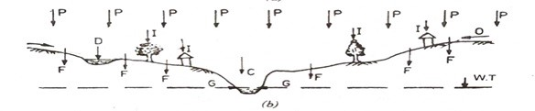

**(3) Near the end of isolated heavy rainfall.** After many hours of heavy rainfall, virtually all depression storage and interception requirements get filled up, the **soil moisture** is also satisfied to a considerable extent, and infiltration rate is near the minimum. The vegetation is saturated and rain falling on it is balanced by an equal amount falling from the vegetation to the ground, except for the extremely small quantity which returns to the atmosphere through evaporation. Similarly, the flow into the filled depressions is essentially balanced by overland flow and infiltration. Thus at this stage, overland flow is the major happening, which takes place over nearly the entire basin, and streamflow begins to bear some relation to the rate of precipitation. Subsurface flow also contributes to streamflow, and underground storage is replenished by **ground water recharge (R)** in some portion of the basin. The happenings taking place at this stage are shown in Fig. (c).

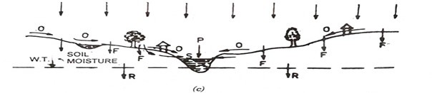

**(4) After the end of rainfall.** When rain and overland flow ceases, the streamflow consists of only the baseflow and the channel storage. Evaporation takes place quite actively from soil moisture, depression and interception storages. Transpiration also starts from the vegetative cover. Water from depression storage also continues to infiltrate. Also, the gravity water, still not drained up to the water-table and present in the zone of **aeration** may continue its downward journey to join the water-table, and thus ground water recharge may continue. The water-table, consequently, may rise or fall, depending upon whether the downward **percolation** rate exceeds or not, the rate at which the ground water is contributing to the flow in the stream channel. The conditions prevailing at this last stage of runoff cycle are shown in Fig. d.

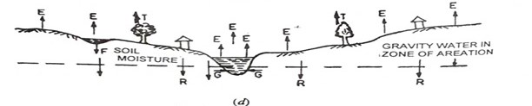

**3.4 FACTORS AFFECTING RUNOFF**

The various factors affecting the runoff, can be divided into two groups: (1) ***characteristics of precipitation***; and (2) ***characteristics of drainage basin*.** Various factors falling under these two beads are discussed below:

*(1) CHARACTERISTICS OF PRECIPITATION*

(a) **Type of Precipitation**. Precipitation generally occurs either in the form of rain or snow. Runoff pattern or the hydrograph of runoff is considerably governed by this factor.

(b) **Rain Intensity**. Rain intensity has a lot of effect on the runoff. If the intensity of rain increases, the runoff increases rapidly. For example, if the intensity is increased four times, the runoff may increase nine times. Thus, an intense rain of the type shown in Fig. a will definitely produce much more runoff than a uniform rain of the type shown in Fig. b, provided the infiltration capacity remains the same throughout the storm period.

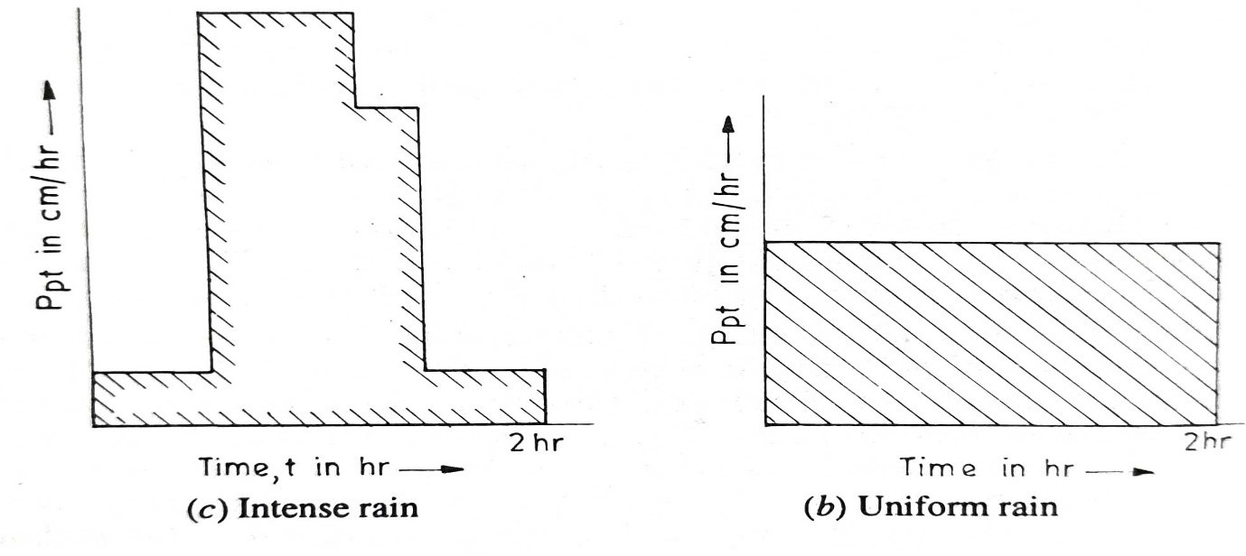

**Fig. 3.3.1**

Although the total amount of rain in Fig. 3.3.1 (a) and (b) is the same, still rain (a) will produce higher amount of runoff, while, rain (b) is likely to produce much less runoff.

(c**) Duration of Rainfall.** Duration of rainfall is important because of the fact that the infiltration capacity goes on reducing during the storm, till it attains a constant value. If the infiltration is less, the surface runoff will be more.

(d) **Areal Rainfall Distribution.** We have considered all the above factors in the light of the assumption that the rain is uniformly distributed over the entire basin; but in actual practice, it generally never happens. The rain may fall either on the whole basin or on a small part of it*.*

(e) **Soil Moisture Deficiency.** The runoff depends upon the soil moisture present at the time of the rainfall. If a rain occurs after a long dry spell of time, the soil is dry and it can absorb huge amounts of water, and thus even intense rain may fail to produce any appreciable runoff. But on the other hand, if the rain occurs after a long rainy season, the soil will be already wet and there may be very less infiltration, and even low intensity rain may cause peak flow and considerable stream rise, sometimes disastrous flood.

(f) **Direction of the Prevailing Storm.** If the direction of the storm is the same as the direction of the movement of the water in the drainage basin, water will remain in the basin for lesser period producing more runoff, as compared to the case when the storm is moving in the direction opposite to the water movement.

(g) **Other Climatic Conditions.** Various other climatic factors, such as temperature, wind, humidity, etc. affect the losses from the drainage basin, and, therefore, affect the runoff. If the losses are more, runoff will be less, and vice versa.

*(2)* **CHARACTERISTICS OF THE DRAINAGE BASIN**

(a) **Size of the Basin.** If the area of the basin is large, the total flood flow will take more time to pass the outlet, thereby the base of the hydrograph of the flood flow will widen out, and consequently reducing the peak flow (because total volume of water passing is the same).

(b) **Shape of the Basin.** The shape of the drainage basin also governs the rate at which water enters the stream. The shape of a drainage basin is generally expressed by ‘Form factor' and **'Compactness coefficient’** **[[***Compactness coefficient is defined as the ratio of the watershed perimeter to the circumference of equivalent circular area.***]]**, as defined below:

**Form Factor** = =

The axial length (l) is the distance from the outlet to the most remote point on the basin, and the average width (B) is obtained by dividing the area (A) by the axial length.

Therefore,

Form factor

Compactness coefficient is defined as:

***Compactness coefficient =***

If A is the area of the basin and r, is the radius of the equivalent circle, then

A=Πre2

Circumference = 2Πre = 2Π.√  = 2. √ΠA

Therefore,

*Compactness coefficient* = .√ΠA where p = perimeter of the basin

A = area of the basin.

There are two types of catchments in general, i.e. (i) fan shaped catchments (ii) fern leaf catchments, as shown in Fig. 3.3.2 (a) and (b). Fan shaped catchments give greater runoff because tributaries are nearly of the same size, and therefore time of flow is nearly the same and is smaller; whereas in fern leaf catchments, the time of concentration is more since the discharge is distributed over a long period, as is evident from the figures.

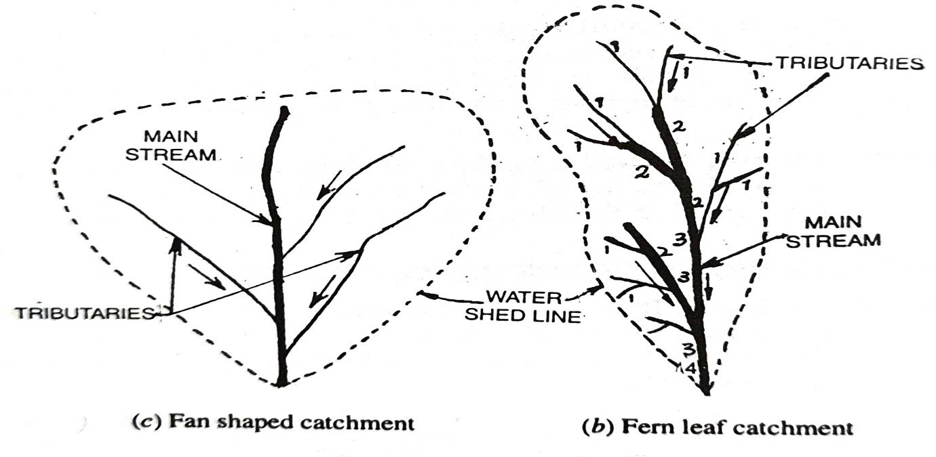

**Fig. 3.3.2 Types of Catchments**

(c) **Elevation of the Watershed.** The elevation of the drainage basin governs the rainfall, its amount, and its type; and hence produces enough effect on the runoff.

The elevation of a water-shed is a variable factor from point to point. In order to determine the average elevation (Z) of the drainage basin, a contour map the basin is taken, and the areas lying between successive contours are measured.

Z is then calculated as:

Z = ; Where A =area of the basin

A1, A2, A3…., are the areas between two successive contours

Z1, Z2, Z3…., are the mean elevation between two successive contours.

**(d) The Type of Arrangement of Stream Channels.** If the **drainage network** (i.e. the arrangement of stream channels) of a catchment is efficient, water will flow rapidly, and will result in a higher peak, as the concentration time will be less. Hence, the more efficient is the drainage, the more flashy the stream flow will be, and vice versa. The characteristics of the drainage net can be fairly described by the four factors: i.e. (i) order of streams; (ii) the length of tributaries;(iii) the stream density; and (iv) the drainage density, as discussed below:

(i) ***Order of Streams.*** All non-branching tributaries, regardless of whether they enter the main stream or its branches, are termed as first order streams. Streams which receive only non-branching tributaries are of the second order. Streams of the third order are formed by the junction of two streams of the second order. A third order channel receives flow not only from two second order channels that form it, but also direct overland flow and possibly from first order channels that run directly into it and possibly from other second order channels that might join it. Thus, a stream of any order has two or more tributaries of the next lower order. The ordering system continues in this fashion. Hence, the junction of two third order streams form a fourth order channel, and so on, as shown by in Fig. 7.3 (6), where order of streams are represented by Figs. 1, 2, 3 & 4 etc.

In accordance with this system, the order number of main stream indicates at once, the extent of bifurcation of its tributaries, and as a rule, is a direct indication of the size and extent of the drainage net.

(ii) ***Length of Tributaries.*** The length of the tributaries is an indication of the steepness of the drainage basin, as well as of the degree of drainage. Steep well-drained areas generally have numerous small tributaries; whereas, in plains, where soils are deep and permeable, only relatively long tributaries (generally perennial streams) will be in existence. This factor, thus, gives the idea of the efficiency of the drainage net.

It is generally better to consider and compare the average length of the same type of tributaries, and especially of the first order of tributaries, than to compare the average length of all tributaries.

(iii) ***Stream Density-***The ***stream density*** or ***stream frequency*** of a drainage basin may be expressed by relating the number of streams to the area drained. If Ns, is the number of streams in the basin, and A is the total area, the stream density Ds, can then be expressed as:

Ds = i.e., the number of streams per sq km.

*In determining the total number of streams, only the perennial and intermittent streams are included.*

This factor does not provide a true measure of drainage efficiency, because a basin having two smaller streams draining only a part of the basin, and another basin of the same size having two larger streams passing through the entire basin, will be indicated to be equally efficient by this factor, whereas it will not be so, the second being certainly more efficient than the first.

(iv) ***Drainage density.*** The ***drainage density*** is expressed as the length of stream per unit of area. Let Dd represents the drainage density, L the total length of the perennial and intermittent streams in the basin, and A the area; then

Dd =

Drainage density varies inversely with the length of the overland flow, at therefore, provides at least some indication of the drainage efficiency of the basin.

(e) ***Other factors.*** Besides these four important characteristics of the drainage basin, other factors, such as, the type of the soil in the catchment, the type of vegetative cover, the slope and orientation of the catchment, etc. are the various factors influencing the runoff. Some of these factors have already been described in the chapter of Infiltration. In fact, all those factors, on which Infiltration depends, can be quoted here also, because all those factors influence the streamflow.

From the above discussion, it becomes quite evident that the streamflow depends upon numerous factors (about 15 to 20 in number) and in order to express the streamflow by an equation is very difficult, because such an equation will involve numerous variables, which are all inter-dependent. Even with the most complicated mathematics, it seems difficult and rather impossible to evolve any generalised formula to evaluate the exact amount of runoff and the peak flow.

**3.5 CERTAIN IMPORTANT TERMS CONNECTED WITH RUNOFF**

**3.5.1. Time of Concentration (TOC).** The time of concentration of a drainage basin is the time required by the water to reach the outlet from the most remote point of the drainage area. When a storm has been in progress for a time equal to the time of concentration, it is assumed that all the parts of the basin start contributing to the discharge at the outlet.

**3.5.2. Travel Time or Time of Flow.** The excess rainfall produced in a basin flows overland on the basin surface, and then through the basin channels, before reaching the outlet point. The time taken by the water to reach the **basin outlet** from the different points in the basin, is called the travel time or the flow time or the time of flow. This flow time will evidently be more for remote points of the basin and shall be less for the points which are nearer to the outlet.

**3.5.3. Period of Surface Runoff.** It is the time taken by the surface runoff (S.R.O.) to pass the given section, after the surface runoff makes its first appearance.

**3.5.4. Period of Rise.** It is the time taken by the surface runoff to reach its maximum value from the time of its beginning.

**3.6 COMPUTING SHORT TERM RUNOFF FROMTHE GIVEN ISOLATED RAINFALL**

The amount of rainfall required is generally termed as **initial basin recharge** and may be denoted L. It includes Pi, Sd, and rain absorbed by the soil moisture deficiency, which depends upon the prevailing soil moisture conditions at the time of rain*. Initial basin recharge is, therefore, the water withheld within the basin before the rainfall starts contributing to the steamflow or the ground water. After the initial recharge of the basin (L) is filled up, the water will infiltrate into the ground as ground water accretion (G), and excess water will flow as* ***direct runoff (Q)***

The total precipitation (P) on a basin can, therefore, be easily represented by the equation.

or

i.e.

This is the fundamental equation for the computation of runoff. Various methods used for computing runoff are enumerated below:

(1) *Computing runoff depth by using runoff coefficient.*

(2) *Computing runoff by using Infiltration Capacity curve.*

(3) *Computing runoff depth by using known/assumed values of infiltration indices (****ϕindex****or* ***Windex****).*

(4) *Computing runoff hydrograph by using Unit hydrograph theory (including the use Bernard's graph, S-curve, and Synthetic unit hydrograph, etc).*

(5) *Computing direct runoff from rainfall using Soil cover conditions.*

All these methods are discussed below:

**3.6.1. Computing Runoff Depth by Using Runoff Coefficient**

The volume of runoff can be directly computed approximately, by using an equation of the form

where Q = Eunoff

P = Precipitation

K = a constant, known as Runoff coefficient, having a value less than 1 or at the most equal to 1. Various values of K, which are commonly used, are shown in Table 3.6.1.

**Table 3.6.1. Values of Runoff Coefficient (K)**

|  |  |  |  |  |
| --- | --- | --- | --- | --- |
| s. No. | Type of area |  | Value of K |  |
| Flat land  O to 5% 810pe | Rolling land  5% to 10% slope | Hilly land to 30% slope |
| (a) | Urban areas  30% area impervious (paved) area impervious (paved) 70% area impervious (paved) | 0.40  0.55  0.65 | 0.50  0.65  0.80 |  |
| (b) | Single family residence in urban areas | 0.3 |  |  |
| 2. | Cultivated Areas  Open Sandy Loam  Clay and Silt Loam  Tight Clay | 0.30  0.50  0.60 | 0.40  0.60  0.70 | 0.52  0.72  0.82 |
| 3. | Pastures  Open Sandy Loam  Clay and Silt Loam  Tight Clay | 0.10  0.30  0.40 | 0.16  0.36  0.55 | 0.22  0.42  0.60 |
| 4. | Wooded land or Forested Areas  Open Sandy Loam  Clay and Silt Loam  Tight Clay | 0.10  0.30  0.40 | 0.25  0.35  0.50 | 0.30  0.50  0.60 |

**3.6.2 Computing Runoff by Using Infiltration Capacity Curve (LC. Curve)**

The infiltration capacity curve is a plot of the infiltration capacity against time. If the I.C. curve is superimposed on the **rainfall hyetograph** the resultant amount will represent nothing but the runoff, as shown in Fig. 3.6.2.

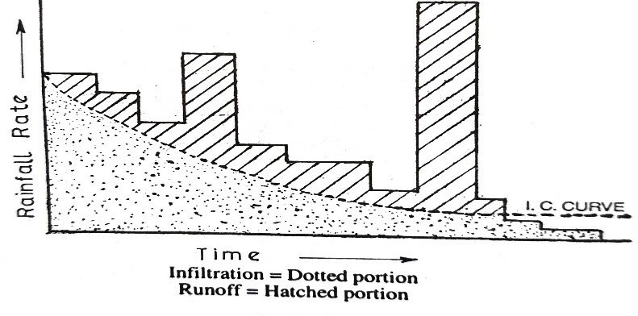

**Fig. 3.6.2**

The above method can be used very easily if the rainfall rate never falls below the infiltration capacity rate. But natural rains of varying intensities, sometimes below and sometimes above the prevailing infiltration capacity, results in a distortion of the capacity time curve. It is generally assumed that the infiltration capacity at any time is determined by the mass infiltration, which has occurred up to that time. Thus, if a rain begins at low rates, and the rainfall during the first hour is two-third of the infiltration in one hour, the capacity rate at the end of the hour will be taken as the capacity that would have prevailed at t = 2/3 hr and not at t = 1 hr.

**3.6.3 Computing Runoff Depth by Using Infiltration Indices**

The runoff depth resulting from some known rainfall can be computed by using the already known or assumed value of infiltration index (i.e., *ϕindex or Windex*). The value of runoff coefficient K can also be determined, if the value of *Windex* is known, by using the equation.

Where, p = rainfall rate.

**3.6.4 Computing Runoff Hydrograph by Using Unit Hydrograph Theory**

So far, we have discussed the methods, which help us in computing single value of runoff, resulting from a given rain value, However, unit hydrograph theory helps us in computing the entire **hydrograph** of surface runoff, resulting from the given rainfall hyetograph. This important theory is discussed below in details:

**3.6.4.1. Unit Hydrograph Theory.** The concept of a unit hydrograph (U.H.), initially called a unit graph, was propounded by Mr. L.K. Sherman in 1932, and provides a very versatile tool for determining the hydrograph of surface runoff resulting from any given amount of d. The method involves the preparation of standard unit hydrographs caused by rainfalls of specified durations, such as 4 hours, 6 hours, 12 hours, etc. This standard T-hour unit hydrograph containing one cm of excess rain is used to work out the hydrograph caused by any other rain of the same duration and containing any other amount of excess rain.

A **T-hour unit hydrograph** is thus defined as the hydrograph of runoff produced by an intense excess rainfall of 1 cm occurring uniformly over the entire drainage basin and at a uniform rate for the short-specified duration of T hour. Since the rainfall excess is nothing but surface runoff, the volume of water contained in the **unit hydrograph** shall be equal to 1 cm depth over the basin area.

The specified duration of T hour was termed by Mr. Sherman as the unit duration, and the storm of this duration was called the unit storm.

The word "unit" in the unit graph was, thus used by its originator to stand for the unit of time, yet however, since its inception, it has often been interpreted to stand for the unit depth (1 cm or 1 inch) of excess rainfall contained in the U.H. The application of a unit hydrograph of 1 cm excess rain for the computation of the direct runoff hydrograph resulting from an excess rain of D cm, or vice versa, is based upon the following assumptions:

(i) ***Time Invariance.*** The runoff produced from a given drainage basin due to a given **effective rainfall** shall always be the same irrespective of the time of its occurrence. In other words, the runoff response of a basin to a given effective rainfall is assumed to be time invariant.

(ii) ***Linear Response.*** The runoff response of a drainage basin to the excess rainfall is assumed to be linear. Linear response means that if an input x1 (t) causes an output y1 (t), and an input x2 (t) causes an output y2 (t), then an input x1 (t)+ x2 (t) will cause an output y1 (t) + y2 (t). In other words, an input equal to D.x1 (t) will cause an output equal to D.y1 (t). It therefore follows that if the excess rainfall of D cm occurs in a duration of T hour, then the resulting runoff hydrograph will have its ordinates equal to D times the ordinates of unit hydrograph. Since the area of the resulting direct runoff hydrograph shall increase by the ratio D, the base of this hydrograph shall be the same as that of the unit hydrograph. The hydrograph of any other storm of specified duration (7 hour) will thus, have the same shape as that of the unit hydrograph of the same duration (7 hour), but with ordinates of flow in proportion to their runoff volumes.

**Limitations of Unit Hydrograph Theory.** The basic assumptions made in defining a U.H. were that: (i) the excess rain should occur uniformly over the entire basin; and (ii) that its intensity should be constant during the entire duration. In actual practice, however, these two conditions are never strictly satisfied, since storms do have non-uniform areal distribution, and their intensities also vary during the specified duration.

**Uses of Unit Hydrograph Theory.** Unit hydrographs as stated earlier, have proved to be excellent tools in analysing the hydrology of a catchment, since they establish a relationship between **Excess Rain Hyetograph (ERH)** and **Direct Runoff Hydrograph (DRH)**. They are chiefly used for:

(i) developing flood hydrographs for extreme rainfall magnitudes, for design of hydraulic structures;

(ii) extending flood flow records by using the available rainfall records;

1. developing **flood forecasting and warning system** based on rainfall data.

**3.6.4.2.** Preparing a Unit Hydrograph from an Isolated Storm. First of all, the runoff rates (in cm/hr) resulting from the given storm are plotted against time (in hours), so as to obtain direct run off hydrograph for the given storm. The total area (D) contained within this hydrograph is calculated by a planimeter or by Simpson's rule, etc. This will represent nothing but the volume of runoff in cm depth of water on the basin.

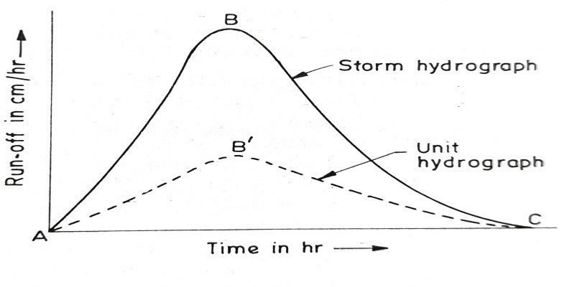

**Fig. 3.6.4.2.1**

The ordinates of this hydrograph ABC (Fig. 3.6.4.2.1) are multiplied by 1 cm/D cm , so as to obtain the ordinates of a unit hydrograph AB'C. For example, suppose the area ABC is 3 cm depth of water, then ordinates of unit hydrograph can be obtained by multiplying the ordinates of storm hydrograph by 1/3.

The final step is to assign an effective storm duration from the study of the storm hyetograph. Periods of low rainfall at the beginning and end of the storm are omitted, if they do not contribute substantially to the runoff, as shown in Fig. 3.6.4.2.2.

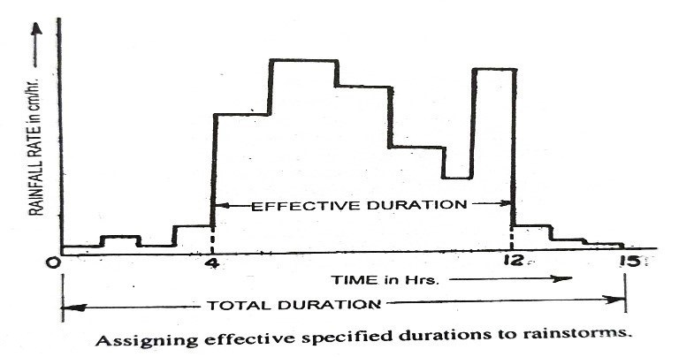

**Fig. 3.6.4.2.2**

In Fig. 3.6.4.2.2, the duration of rainfall is 15 hours, but still it can be assumed to have an effective duration equal to 8 hours. In this way, the number of durations can be reduced, and several storms of different durations can be assigned the same unit duration. Unit storms are, therefore, not the storms of the same durations, but they are the storms of the like durations.

**3.6.4.3.** Preparing Runoff Hydrograph for the Design Storm. The unit hydrograph of a specified unit duration, such as 6 hr U.H. obtained from the past data can be easily used to obtain the hydrograph of future storms of the like durations, provided the volume of runoff resulting from such a storm is estimated. The total volume of run off (in cm) resulting from a storm, when divided by 1 cm, will give us the multiplying factor, i.e. the factor by which the ordinates of the unit hydrograph must be multiplied in order to obtain the ordinates of the direct runoff hydrograph, as shown in Fig. 3.6.4.3.

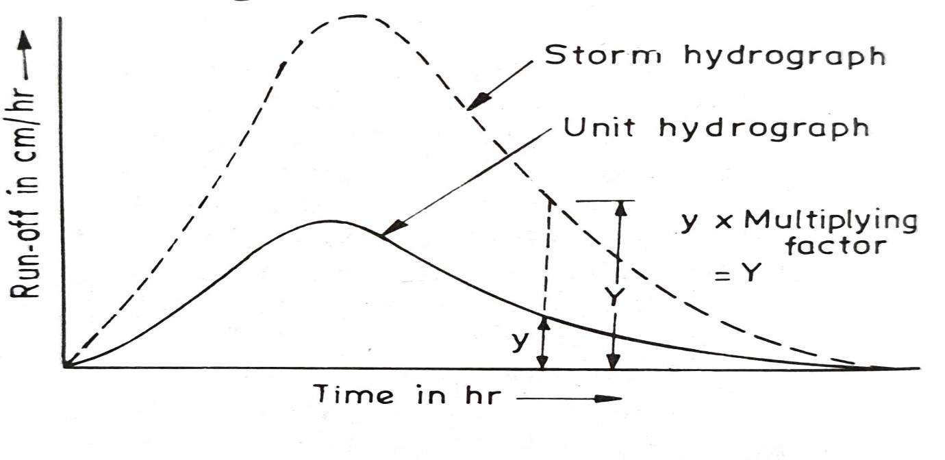

**Fig. 3.6.4.3**

The unit hydrograph of a specified duration (t1) can also be used to evaluate the runoff hydrographs for storms of longer durations (t2), which are integral multiples of the given duration. Say for example, a 4 hr unit hydrograph can be used to compute the hydrograph of a storm of 8 hr duration. This is accomplished by dividing the longer storm into two parts. The hydrographs of runoff for each part are computed separately and added. But care should be taken to see that the hydrograph of the second part of the storm will start 4 hours later than that of the first part. This will become more clear when we solve a numerical example, a little later.

A tolerance of about 25 per cent of the adopted unit hydrograph duration is generally accepted without serious errors. Thus, a 4 hour-unit hydrograph might be applied to storms of 3 to 5 hours effective durations.

Sometimes, the unit hydrographs having similar range in durations, are averaged to obtain an **average unit hydrograph**

. An average unit hydrograph is preferred to a single storm unit hydrograph, since the averaging tends to minimise errors in the data.

Large variations in the rainfall intensity during the unit period may considerably affect the accuracy of the unit hydrograph approach. Errors due to this reason, can be reduced by using unit hydrographs for relatively short time periods. The short periods of unit hydrographs can be used to develop the hydrograph resulting from a long rain of varying intensity. Experience has shown that the best unit period is about one-fourth of the basin lag, i.e., the time from the centre of mass of rainfall to the peak of the hydrograph.

**3.7** **Bernard's Distribution Graph**

A distribution graph is somewhat similar to a unit hydrograph in the sense that it is a plot having the same time scale on z-axis as in a unit hydrograph, but the ordinates on y-axis are not the S.R.O. rates as in a unit hydrograph, but the percentage of total S.R.O. that occurred during successive arbitrarily chosen time intervals. This graph is more rational than a unit hydrograph in the sense that all the unit storms irrespective of their magnitude, produce almost identical distribution graphs. Now, once a D-graph is derived for a drainage basin (from the runoff hydrograph of a unit storm), it serves as a means of converting any expected volume of surface runoff (i.e. excess or effective rainfall) into hydrograph of river discharge.

It can also be stated here that the time interval chosen for the D-graph percentages, has no bearing in relation to the duration of rainfall excess, and the magnitude of this interval depends entirely upon how accurate a reproduction of the hydrograph is desired, and upon the time available for computations. Usually, this interval is taken as 0.1 times the total period of the hydrograph (i.e. the base).

For obtaining the distribution graph, therefore, the hydrograph of unit storm must be divided into a suitable number of time intervals.

The area under each strip is calculated, which is expressed as percentage of the total area under the unit graph.

Say for example, in Fig. 1.16, the unit hydrograph is divided into 10 intervals each of 10 minutes unit duration, and let areas under these strips be a1, a2, a3 …., 910 and let the total area be a1+a2+... a10=A.

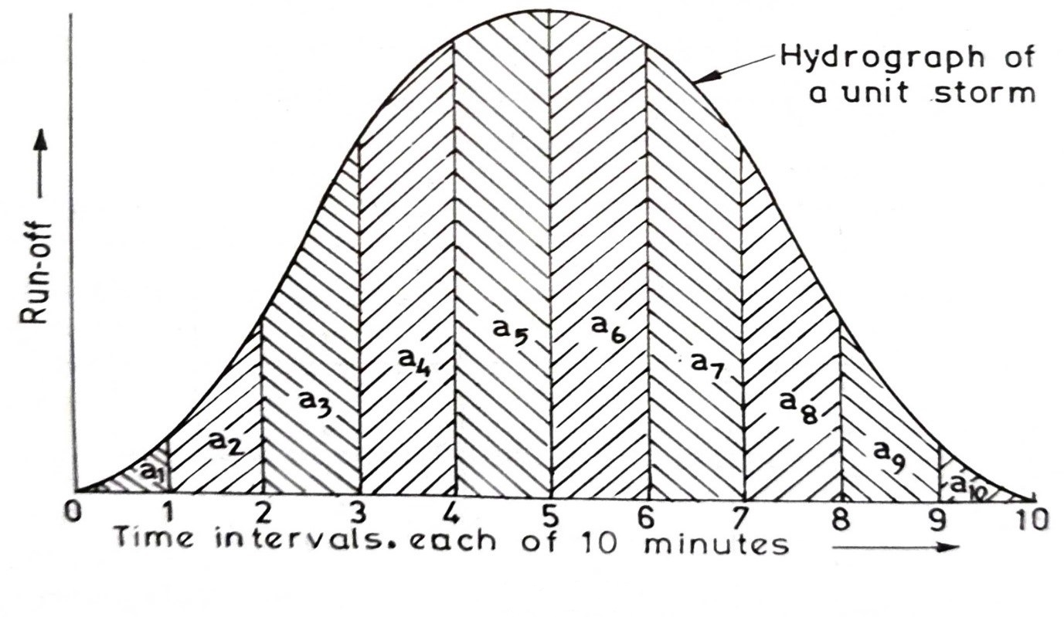

**Fig. 3.7**

The ordinates y1, y2, y3….,y10 are plotted on y-axis against the corresponding strip (centre point of each strip). They are joined together, so as to obtain the distribution graph.

The simplest method to calculate y1, y2, y3... y10 in the above case, would be, to measure the ordinate at the centre point of each strip and to divide each by their sum. Let q0-1 be the ordinate of S.R.O. between 0 and 1, and similarly, q1-2 be the ordinate of S.R.O. between 1 and 2, and so on, then

Since q0-1, q1-2, q2-3, etc. will, in the above case, be the S.R.O. in cumecs corresponding to time intervals of 5, 15, 20 ... minutes; and hence even plotting of unit hydrograph is not required, if the S.R.O. ordinates are given corresponding to the mid-intervals.

**3.7.1. Separation of the Base Flow from Discharge Hydrograph.**

In separate the base flow from the flow hydrograph of a stream. In other words, the surface runoff and ground water discharge must, first of all, be separated.

The method of separating the ground water discharge from the runoff has been discussed earlier, and the line representing the base flow must be drawn in that manner, on the runoff hydrograph curve. Generally, the point of beginning of S.R.O. can be easily detected, because of the abrupt fashion in which the hydrograph rises at that point. While, the end point can be detected from the fact that at this stage, there is a sudden break in the slope of the recessional curve.

Sometimes, when other methods for detecting the starting point and end point fail, these points may be arbitrarily chosen, depending upon the personal judgement.

When two overlapping unit hydrographs are involved, they are also separated into single hydrographs. This is illustrated in Fig. 1.20. The recession side of the 1st hydrograph is assumed to be the same as that of the 2nd hydrograph.

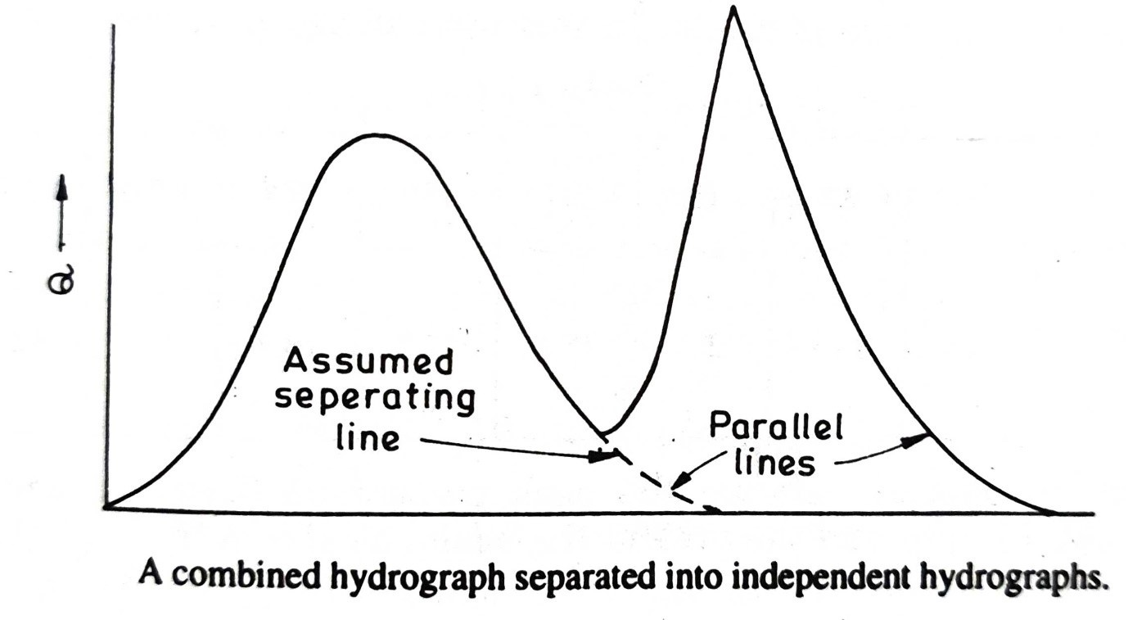

**Fig. 3.7.1**

**3.7.2. Distribution Graphs for Different Water-sheds.**

The distribution graphs for different unit storms and for a given basin have been found to exhibit a marked similarity, and are almost identical. Thus, a typical distribution grape for a given drainage basin is derived and kept in the office, so as to re-use it, in order to predict the runoff in future.

In actual practice, distribution graph derived above is used not only to predict the runoff from the drainage basin for which it is derived, but also for any other drainage basins having almost similar physical characteristics.

Various experiments have been performed, and it has been found that the area of the basin exerts a considerable influence on the shape of the unit hydrograph, although it is not the only factor. Other factors like slope, shape, stream density, etc, do affect it.

**Table 3.7.2.1**

|  |  |  |  |  |
| --- | --- | --- | --- | --- |
| ***Area of the basin in hectares*** | ***Period of rise in minutes*** | ***Length of base in minutes*** | ***Peak percentage based on intervals equal to 0.1 of base*** | ***Duration of chosen time interval for D-graph in minutes*** |
| **29**  **30**  **49**  **121**  **149**  **368**  **1028**  **1830**  **2140** | **27**  **26**  **27**  **31**  **42**  **73**  **63**  **104**  **110** | **100**  **120**  **130**  **200**  **210**  **300**  **290**  **560**  **580** | **32.0**  **38.1**  **34.2**  **37.7**  **37.6**  **31.7**  **34.1**  **38.9**  **37.9** | **10**  **12**  **13**  **20**  **21**  **30**  **29**  **56**  **58** |

The distribution graphs drawn for various basins of different areas show marked similarity, when the base of the unit hydrograph is divided into equal number of intervals. Their peak values are found to be almost equal, as shown in Table 3.7.2.1.

But the peak percentages based on uniform time intervals, say (10 minutes interval) are not uniform, and found to vary inversely with the area. The values were reducing as the area of the basin was increasing, as shown in Table 3.7.2.2.

**Table 3.7.2.2**

|  |  |  |  |  |  |  |  |  |  |
| --- | --- | --- | --- | --- | --- | --- | --- | --- | --- |
| ***Basin area in hectares*** | **29** | **30** | **49** | **121** | **149** | **368** | **1028** | **1830** | **2140** |
| ***Peak percentage based on 10 min. interval*** | **32.6** | **30.4** | **25.1** | **18.3** | **17.2** | **10.4** | **8.1** | **6.8** | **6.1** |

Graphs are plotted between the peak percentage (based on uniform time intervals, say 10 min) and the area of the basin, as shown in Fig. 3.7.2.

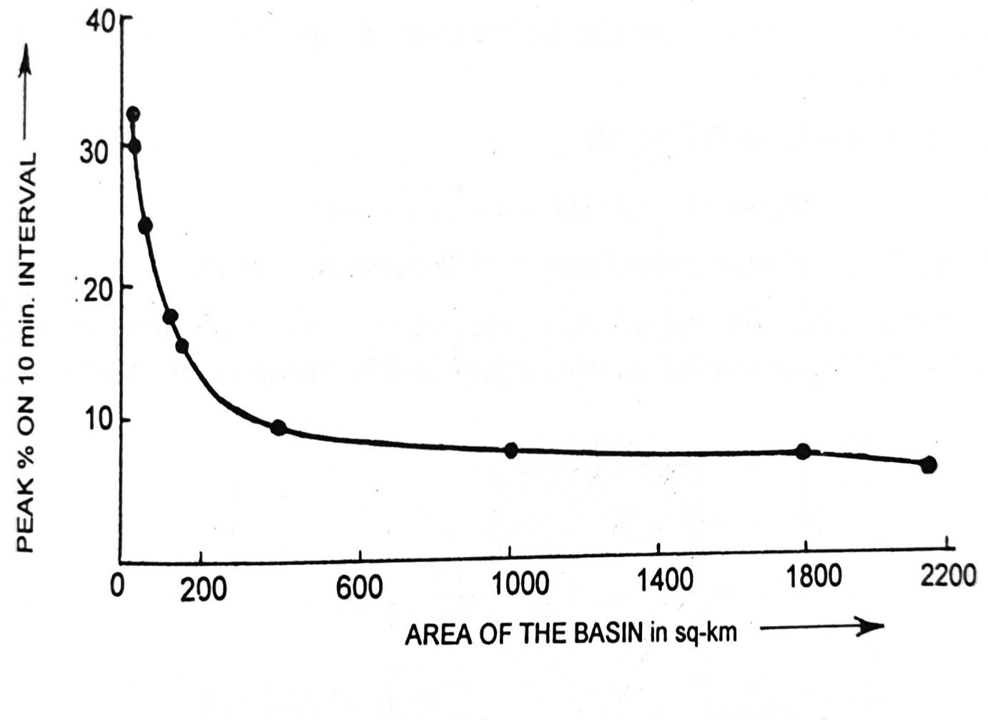

**Fig. 3.7.2**

**3.8 Computation of Runoff Hydrograph from Excess Rainfall by Using D. Graph.** The distribution graph can be easily used to compute the hydrograph of direct runoff or peak runoff rate, if the effective rainfall (excess rainfall) is known. This can be done by a single application of the D. graph, if the duration of the effective rainfall is less than the critical rainfall duration, which is usually considered equal to the period of rise for smaller catchments (up to 2500 hectares or so). This use of D. graph will become clearer when we solve the following numerical examples. However, the hydrograph, resulting from a rain of longer duration (i.e., greater than the period of rise) must be derived by successive applications of D. graph to unit durations of effective rainfall.

**CHAPTER-4**

**4.1. S-CURVE HYDROGRAPH**

When a unit hydrograph of a desired unit duration (2) is neither available nor can be developed by analysis of the rainfall runoff data, then we are left with no alternative but to somehow or the other, derive this hydrograph from the known hydrograph of some other duration (f). The problem is simple, when the unknown hydrograph duration is an integral multiple of the known hydrograph duration. The computations in such a case are relatively easy. Say for example, a known unit hydrograph of say 3 hr duration can be easily used to compute the unit hydrograph of 6 hr duration by superimposing the known 3 hr unit hydrograph, over the 3-hr unit hydrograph plotted with a time lag of 3 hr; and then dividing each ordinate by 2.

The problem is, however, complex when the duration of the unknown hydrograph is shorter or not an integral multiple of the duration of the known hydrograph. In such situations, a S-hydrograph i.e., summation curve hydrograph, based on the principle of superposition, is, first of all, constructed; and then used to compute the hydrograph of any desired duration (t2).

The S-hydrograph or S-curve is essentially a hydrograph produced by a continuous effective rainfall at a constant rate for an indefinite period. The S-hydrograph is a continuously rising curve, which ultimately attains a constant value, when equilibrium discharge is reached, after the entire catchment starts contributing to runoff.

**4.2. Determining S-curve.** The S-curve for a t1hr unit hydrograph can be determined on the principle that: the S-curve lagged by t1hr when subtracted from the S-curve gives us nothing but the unit hydrograph of t1 hr. In other words, when we add unit hydrograph ordinates with the ordinates of S-curve-lagged by t1hr, we get the ordinates of S-curve. Moreover, the initial ordinates of S-curve as well as the above imaginary offsetted S-curve, are the same as unit hydrograph ordinates. This principle can be easily used to compute S-curve ordinates, by simultaneously computing S-curve ordinates as well as offsetted S-curve ordinates from the known U.H. ordinates.

**4.3. Using S-curve for Determining Unit Hydrograph of Unknown Duration (t2).** When once the S-curve has been derived from the given t1hr unit hydrograph, we can easily use it to derive the U.H. of another duration 2, as discussed below:

Assume that the S-hydrograph has been produced by continuous effective rainfall of a constant rate of q mm/hr. Then, advance or offset the position of this S-hydrograph for a period equal to the desired duration of 12 hours, as shown by curve 2 in the figure. This can be called a "shifted" or "lagged" S-curve. The difference between the ordinates of the original S-curve and the shifted S-curve, divided by would result in the desired unit hydrograph.

q can be computed easily from the 1 cm net rain contained in the U.H. of known duration (t1), as

Therefore,

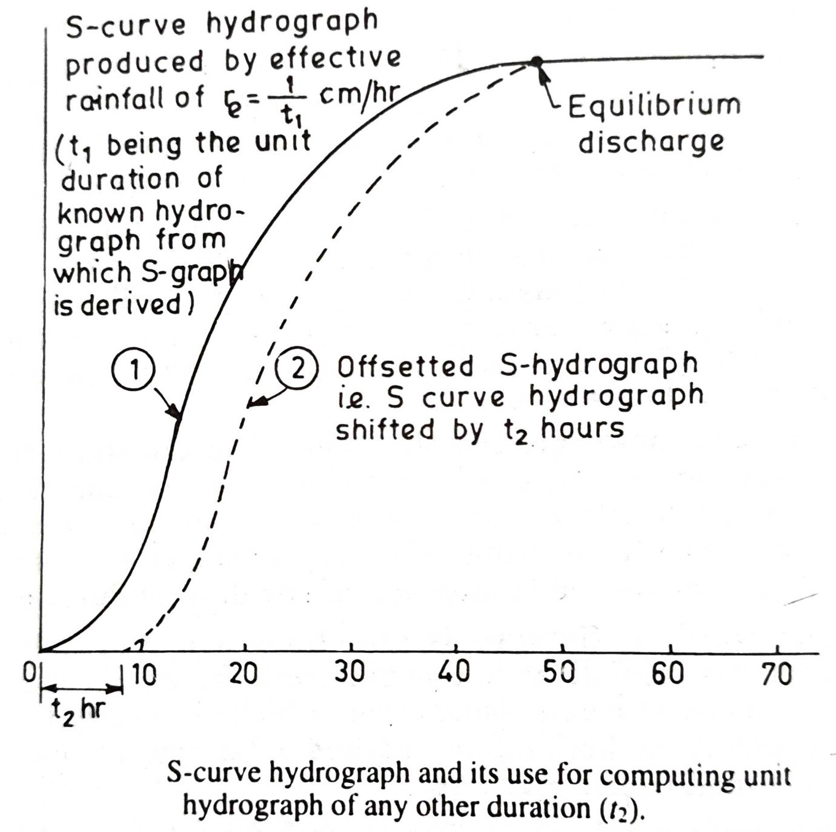

**Fig. 4.3**

Therefore,

Hence, the difference in the ordinates of S-curve and shifted S-curve, should be divided by the factor t2/t1, i.e. multiplied by t1/t2, so as to obtain the ordinates of unit hydrograph of duration t2.

The constant discharge of S-hydrograph at the time of equilibrium can also be obtained as:

Where, q is the effective rainfall rate in cm/hr, and A is the catchment area in sq.km.

Or

Or

Or for 1 cm unit hydrograph

Also, for 2.5 cm unit hydrograph

Where Q is in cumecs; A is in sq km; t is in hr.

**CHAPTER – 5**

**5.1. SYNTHETIC UNIT HYDROGRAPH**

If rainfall-runoff data is available for a basin, its unit hydrograph can be derived by using the methods described earlier. However, there are many basins, especially in developing countries, which are not gauged; but for which, unit graphs may be required. For such basins, the unit hydrographs are synthesised from the known unit hydrograph of a meteorologically homogeneous basin.

The characteristics of the basin for which unit graph is known, are, therefore, correlated with the unit graph characteristics; and the established correlation is then used to determine the characteristics of the unit graph for the known basin characteristics of the ungauged basin. The unit hydrograph, thus, determined for the ungauged catchment, is known as synthetic unit hydrograph.

Several techniques are adopted for establishing a relationship between the basin characteristics and the unit graph characteristics, for a unit rainfall, but the most commonly used one is by Snyder, and hence is known as Snyder's method, as discussed below.

Snyder (1938), based on a study of a large number of catchment basins in the Appalachian Highlands of Eastern United States, developed a set of empirical equations, connecting the basin characteristics with the unit graph characteristics.

The basin characteristics used in these empirical relations were L, Lc, A, and coefficients Ct, and Cp; whereas the unit graph characteristics were tp, B and Qp. The equations developed are:

(i)

Where; tp = **Basin lag**, which is the time interval from the midpoint of the unit rainfall excess to the peak of the unit graph.

L = Length of the main stream in the catchment up to the gauging site, in km.

Lc = The distance along the main stream from the gauging site to a point on the stream which is nearest to the centroid of the basin, in km.

Ct = Regional constant representing the watershed slope and storage. It was found to vary between 1.35 to 1.65 for basins studied by Snyder in Appalachian mountain region (USA). However, wide variations between 0.3 to 6.0 have been reported over a variety of basins, over the world.

(ii) Snyder adopted a standard rainfall duration of t hours (unit duration), given by

(iii) The peak discharge Qp of a unit hydrograph of standard unit duration oft hour is given by Snyder as:

Where in m3/s

A = catchment area in km2

Cp = a dimensionless regional constant, representing the retention and storage capacity of the basin. Its value was found to vary between 0.56 to 0.69 for basins studied by Snyder. However, wide variations between 0.31 to 0.93 have been reported in the study of variety of basins, over the world.

(iv) If a non-standard unit duration equal to T hour is used in place of the standard duration of t hour, then the value of the basin lag is affected, and its modified value (Tp) is given by

or 𝑇𝑝 = 21/22 𝑡𝑝 + 𝑇/4

Thus, for a non-standard duration (T), the term Tp, must be used in place of tp, and hence, the peak discharge of unit hydrograph, is given by Eqn. as:

(v) The time base of this unit hydrograph, T, in hours, is further given by Snyder as:

The above equation of time base, as given by Snyder is generally suitable for large catchments; whereas, it has been observed to be giving an excessive value for smaller catchments, for which Taylor and Schwartz has recommended another equation, as:

With the above chief characteristics of a unit graph determined, i.e. Tp, Qp and Tb, the graph can be sketched, roughly as a triangle. However, U.S. Army Corps of Engineers have further postulated the widths of the hydrograph at discharges equal to 50% and 75% of peak discharge, as equal to:

And

Where; W50 = Width of unit graph in hr. at 50% peak discharge.

W75 = Width of unit graph in hr. at 75% peak discharge.

Usually, 1/3 of these widths are distributed before the unit graph peak, and after the peak, as shown in Fig. 5.1.

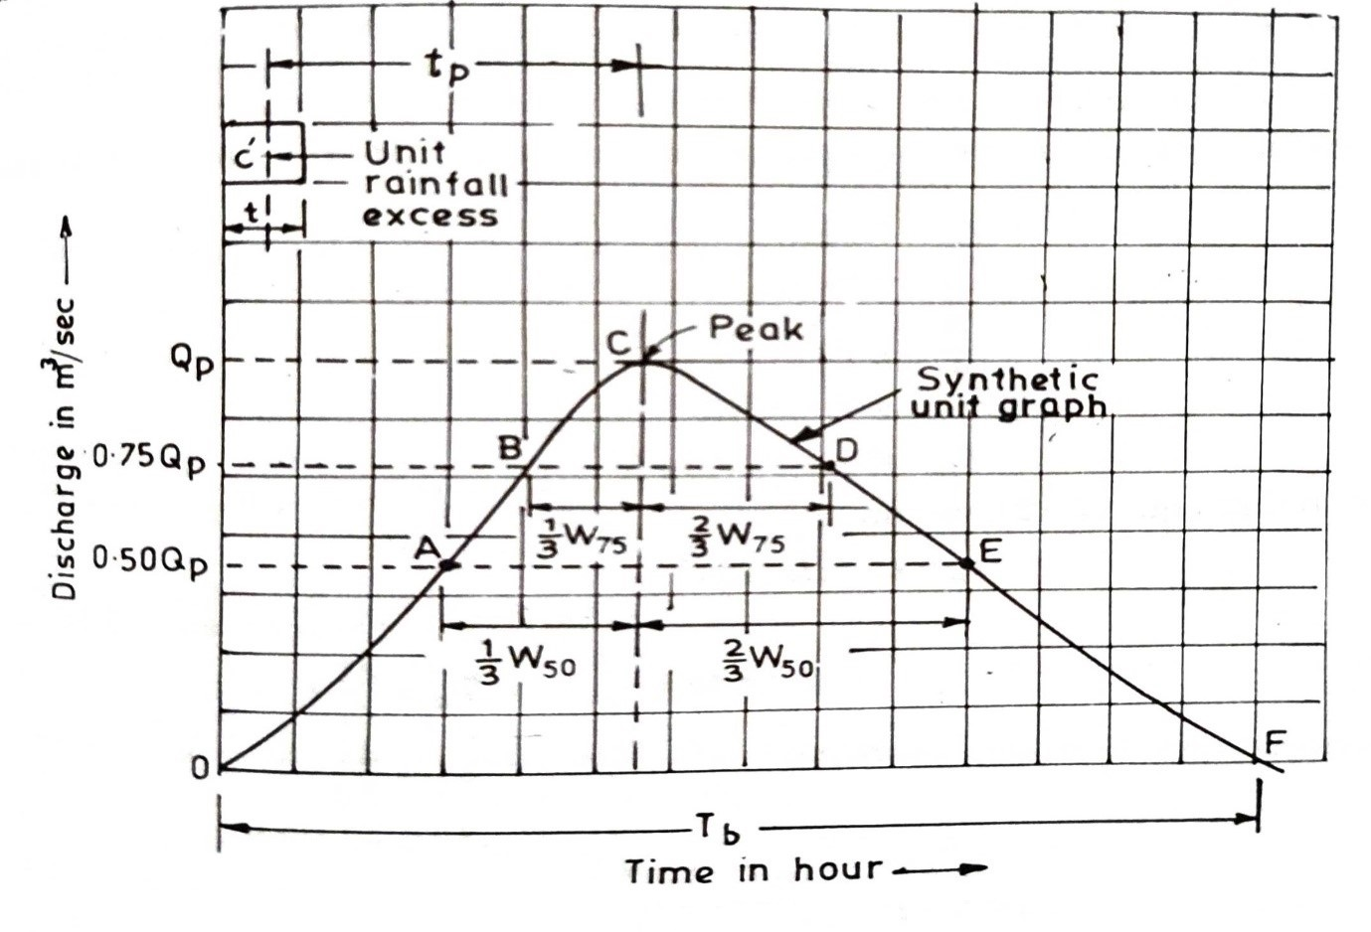

**Fig. 5.1**

Moreover, as stated earlier, the coefficients C, and C, may vary from region to region; and it is advisable to determine their values for the basin for which unit hydrograph is known, and then to utilise these values for the ungauged basin, which is meteorologically homogeneous with the earlier one.

Some investigators, after Snyder, such as Linsley, have further given a modified equation for tp as:

where; S = basin slope expressed as dimensionless ratio

n = basin constant, found to be 0.38 by Linsley for U.S. catchments.

CL = Another basin constant, found to be 1.715 for mountainous areas, 1.03 for foot hill areas, and 0.50 for valley drainage areas.

**5.2. Indian Equations for Synthetic Unit Hydrograph.** The Central Water Commission, after making a study on a large number of Indian catchments of sizes ranging between 25 to 500 km², has recommended the following relations for developing synthetic unit hydrographs:

(i) The peak discharge for a T-hr unit hydrograph in m³/s is given by :

Where A = Catchment area in km²

Sm = Weighted mean slope given by Eqn. as

Where L1, L2... Ln are the lengths of the main channels having slopes S1, S2.... Sn, respectively, as obtained from the topographic map.

(ii) The lag time or basin lag in hours (i.e. the time interval from midpoint of the Excess Rainfall to the peak of 1-hour unit hydrograph), tp1, is given by

For design purposes, the duration of excess rainfall is taken as

**5.3 Average Unit Hydrograph**

The runoff pattern resulting from a unit storm of a particular duration will lead to the derivation of a unit hydrograph of that duration; but since for a particular site at a given river, there may exist various storms on records with their runoff observations. In that case, there may exist a number of unit storms of the same (or like) durations, which will result in unit hydrographs, which may be slightly different from one another. In that case, we try to average out all these hydrographs, and thus to get one single average representative standard hydrograph of that duration. In so doing, effort should be made to choose only those isolated uniform intensity storms, for which the data is quite reliable.

When once such isolated storms have been chosen, and their unit graphs plotted; the average unit hydrograph is computed. It may however, be understood that in this averaging, the ordinates of the hydrographs are not averaged, as that would produce an untypical peak. In fact, the peak values of the isolated unit hydrographs are averaged, as are the values of the time from the start of runoff to the peak. These average values of time and peak are assigned to the average unit hydrograph, which is then sketched into a median form on both rising and falling limbs, so that the total area under the curve is equal to 1 cm of runoff.

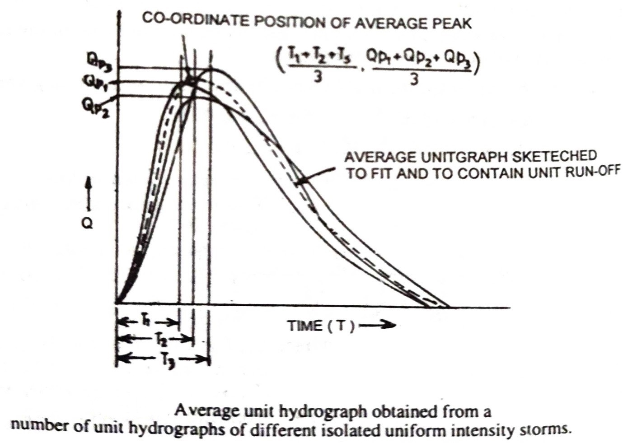

**Fig. 5.3**

**5.4. Instantaneous Unit Hydrograph (IUH)**

The ordinary UH, as you know by now, is obtained from an excess rainfall (ER) of 1 cm magnitude, uniformly falling during a time period of T hour, with an intensity equal to 1/T cm/h. If this rain duration (T) is progressively decreased, its intensity will go on increasing, and

the resulting unit hydrograph will become more skewed as shown in Fig 1.34, by hydrograph marked 2. The hydrograph will

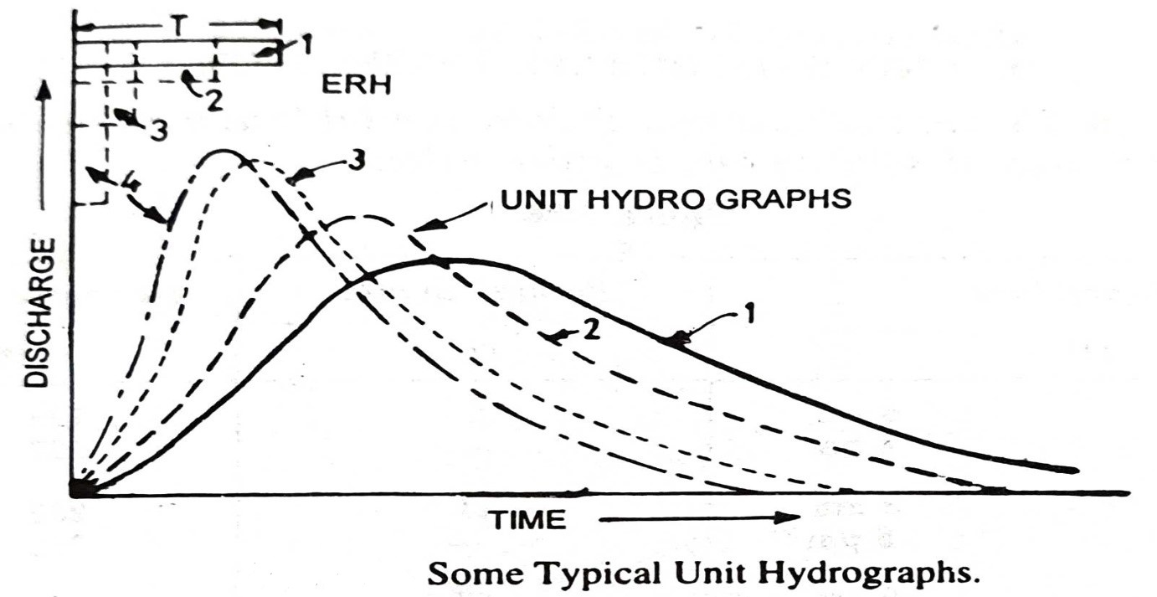

**Fig. 5.4**

go on becoming more and more skewed with progressively reduced value of T, as shown by unitgraphs marked 3 and 4. A more skewed but certainly of finite shape unit hydrograph will finally be obtained when the rain duration T is made infinitesimally small (T -->0). This limiting case of a unit hydrograph produced by a rainfall of 1 cm in zero time" is called an instantaneous unit hydrograph. Of course, this is only a theoretical concept, because 1 cm of rain cannot fall in a zero time on any catchment, but it is useful because such a unit graph represents the watershed's response to a rainfall without reference to the duration of the rainfall. An IUH, being independent of rainfall characteristics, is indicative of the storage characteristics of a catchment, and is eminently suitable for theoretical analysis of effective rainfall-runoff relationship of a catchment.

The ideal shape of a IUH resembles that of a single-peaked direct runoff hydrograph; yet however, an IUH can have negative and undulating ordinates.

The IUH for a catchment can be derived from a given ERH (Excess Rain Hyetograph) and DRH (Direct Rain Hydrograph) by several methods. Say for example, the ordinate of an IUH at any time t has been shown to be equal to the slope at time t of the S-curve, caused by an excess rain of intensity of 1 cm/h (i.e. S. curve derived from a U.H. of 1-h duration). The IUH so obtained is in fact an approximate one, because the slope of the S curve is difficult to be measured accurately.

***CONCLUSION AND FUTURE SCOPE***

This synopsis is made to realize the importance of Synthetic Unit Hydrograph and also the necessities of such a thing even after already having a hydrograph. The main aim is to understand the various techniques needed for establishing a relationship between the basin characteristics and the unit graph characteristics, for a unit rainfall of an ungauged basin; wherein the Synthetic Unit hydrograph theory is of utmost importance. Our goal is to study Snyder’s theory (1938) for Synthetic Unit hydrograph in detail, based on a study of a large number of catchment basins in the Appalachian Highlands of Eastern United States, developed a set of empirical equations, connecting the basin characteristics with the unit graph characteristics; thereby ultimately develop a synthetic unit hydrograph on our own at the end of the project. The synopsis also includes the analysis of three hydrograph characteristics which Snyder found relationships between; those are effective rainfall duration(tr), the peak direct runoff rate(qp) and the basin lag time(ti). Synopsis is mentioned about our way of approach and also the purpose of simulation of basin diffusion by estimating the basin lag based on a certain formula or procedure.

We can use the Snyder’s method to generate a Synthetic Unit Hydrograph of a remote area by using the known equations.

***DEFINITIONS***

1. **[[***Subsurface flow refers to the flow of water below earth's surface as part of the hydrologic cycle]].*

**2. [[***Streamflow, or channel runoff, is the flow of water in streams and other channels and is a major element of the water cycle]].*

3. **[[***Depression storage refers to little low spots on undulating terrain that can retain precipitation that would otherwise become runoff]].*

4. **[[***potential infiltration rate, of a soil is the maximal rate at which the soil surface can absorb water]].*

5. **[[***That part of the rain which remains on the ground surface during rain and either runs off or infiltrates after the rain ends]].*

6. ***[[****The maximum flow of a stream in response to a rainstorm event. Evapotranspiration is the combined processes by which water moves from the earth’s surface into the atmosphere. It covers both water evaporation and transpiration]].*

7. **[[***Evaporation is a type of vaporization that occurs on the surface of a liquid as it changes into the gas phase]].*

8. **[[***Transpiration is the process of water movement through a plant and its evaporation from aerial parts, such as leaves, stems, and flowers]].*

9. **[[***It is defined as the "part of streamflow that has infiltrated the ground, entered the phreatic zone, and has been (or is at a particular time) discharged into a stream channel or springs; and seepage water]].*

10. **[[***Infiltration is the downward entry of water into the soil. The velocity at which water enters the soil is infiltration rate. Infiltration rate is typically expressed in inches per hour. Water from rainfall or irrigation must first enter the soil for it to be of value]].*

11. **[[***Overland flow is the movement of water over the land, downslope toward a surface water body]].*

12. **[[***The difference between the amount of water actually in the soil and the amount of water that the soil can hold]].*

**13. [[***groundwater recharge occurs as precipitation falls on the land surface, infiltrates into soils, and moves through pore spaces down to the water table]].* **14. [[***Aeration (also called aerification) is the process by which air is circulated through, mixed with or dissolved in a liquid or substance]].*

**15. [[***Percolation can be defined as the flow of fluids through a porous media (filter). Infiltration rate may be defined as the meters per unit time of the entry of water into the soil surface regardless of the types or values of forces or gradients. Water entry into the soil is caused by matric and gravitational forces]].*

**16.[[***A drainage basin is an area of land where water from rain or snow melt drains downhill into a body of water such as a river, lake, wetland, or ocean. The drainage basin includes both the streams and rivers that convey the water as well as the land surface from which water drains into those channels]].*

17. **[[***Compactness coefficient is defined as the ratio of the watershed perimeter to the circumference of equivalent circular area]].*

18. **[[***any point on the main drainage system can be selected as the basin outlet. Thus, a basin is defined with respect to the outlet. The physical boundary of the drainage basin is called the drainage divide]].*

**19. *[[****It is a rate of infiltration in which, the rate of infiltration exceeds the value at which the volume of runoff becomes equal to the volume of rainfall]].*

***20. [[****This is the average infiltration rate during the entire period of rainfall. In the calculation of the W-index. Initial loss is not treated as infiltration quantity]].*

*21.* **[[***The hyetograph that we get after subtracting losses from the actual rainfall is called the excess rainfall hydrograph***]].**

**22. [[***A chart or graph showing changes in water quantity in a stream or river over time***]].**

***REFERENCE***

* Applied Hydrology; Ven Te Chow